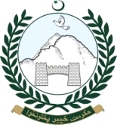



091- 9225344, 9225339 Fax- 091-9225345

**Dated Peshawar March, 11, 2018**

**UNDERTAKING**

It is solemnly declared that neither the undersigned nor my wife/ dependents hold dual nationality.

Name **SAHIBZDA HAMID MAHMUD**

SON of **MAHMUD UL HASSAN AKHTAR**

Designation ADDL. DIRECTOR(ESTT)

CNIC **17301-5786288-9**

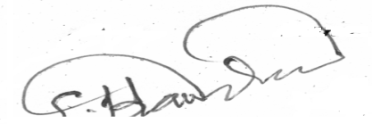

Signature